**Day 4 task**

Explain in your own words and examples, what is Shell Scripting for DevOps.

* A shell is a command-line interpreter and typical operations performed by shell scripts include file manipulation, program execution, and printing text.
* A bash script is a plain text file that contains a series of commands.
* we will open the file vi/vim editor and add some commands in it.
* It is a convention to give files that are bash script an extension of .sh (file.sh)

**For example**

$vim print.sh

#!/bin/bash

1. What is #!/bin/bash? can we write #!/bin/sh as well?

" #! "called as SHEBANG character, it tells the script to interpret the rest of the lines with an interpreter/bin/bash.

Bash (Bourne again shell) is a shell replacement for the Bourne shell. Bash is a superset of sh.#!/bin/bash . and yes we can use #!/bin/sh instead of #!/bin/bash

1. Write a Shell Script which prints I will complete #90DaysOofDevOps challenge

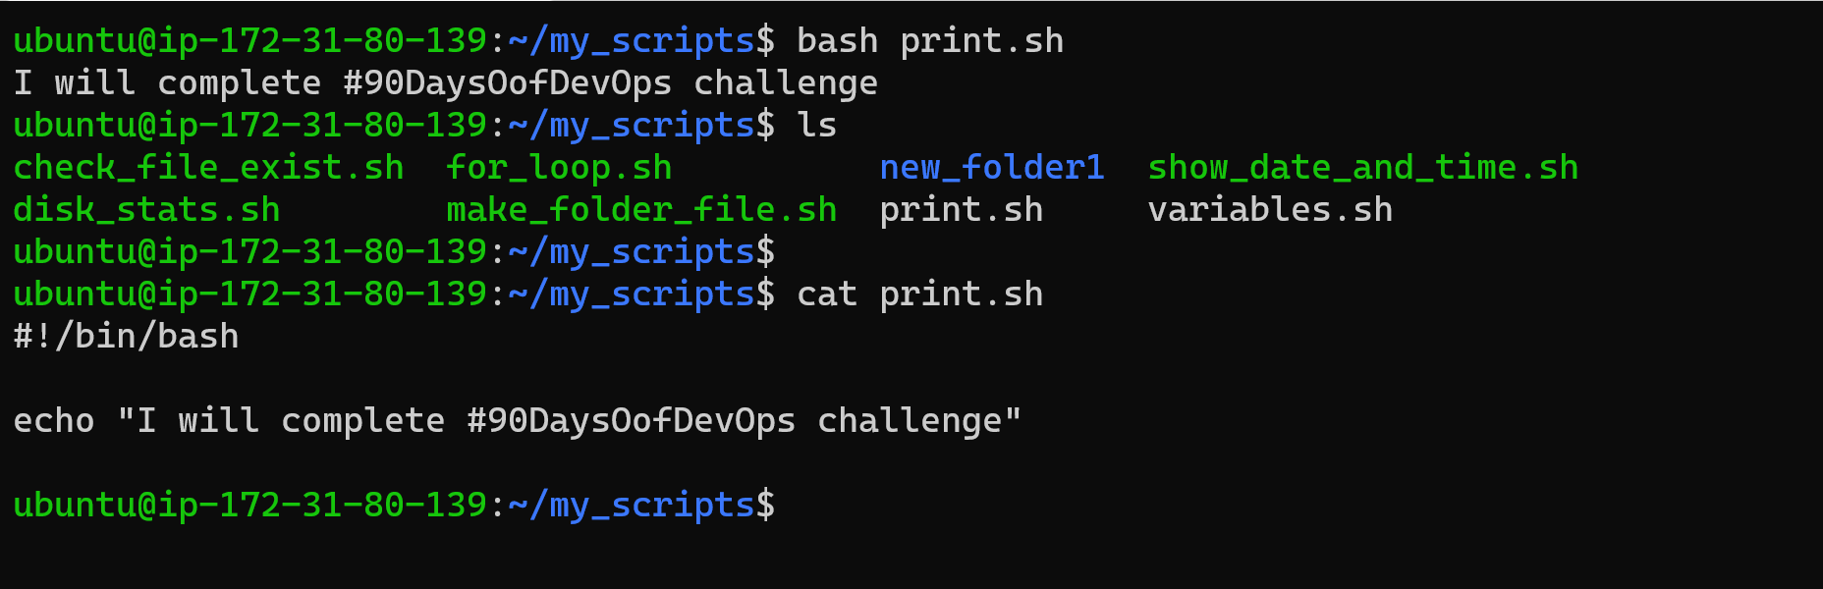

1. Write a Shell Script to take user input, input from arguments and print the variables.

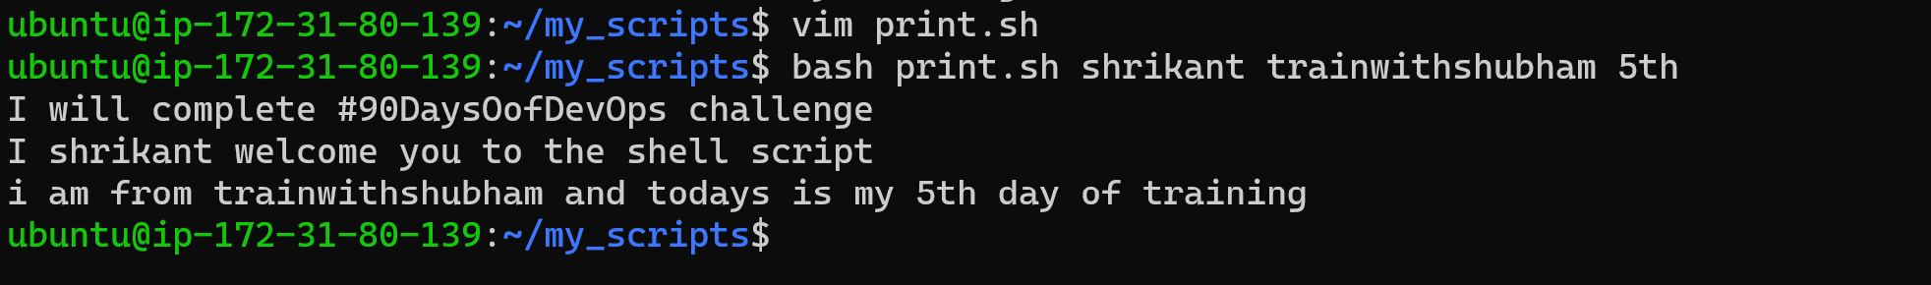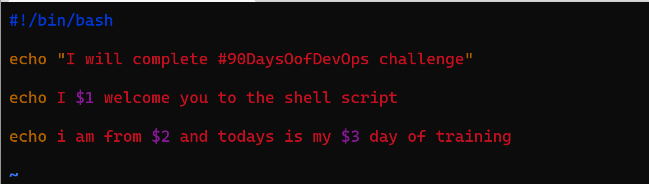

1. Write an Example of If else in Shell Scripting by comparing 2 numbers\

